**Computerized Library Management System**

**(CLMS)**

**Proponents:**

**Villena, Clifford T.**

**Garcia, Edrick C.**

**Buna, John Michael**

**Dela Cruz, Roldan P.**

**April 2023**

**Chapter I: Introduction of the study**

**1.1: Introduction and its Background**

Libraries have played an integral role in society for centuries, serving as repositories of knowledge and providing access to resources for a wide range of users. With the advent of digital technology, libraries have evolved to meet the changing needs of their patrons, offering access to resources and tools to facilitate research and learning.

Despite these changes, however, libraries continue to face challenges in meeting the needs of their users. These challenges include limited budgets, staffing constraints, and changing patterns of user behavior. In order to remain relevant and effective in the 21st century, libraries must adapt to these challenges and find innovative ways to meet the evolving needs of their communities.

To meet the demands of library users, the process of managing and directing a library's facilities, services, and resources is referred to as library management. Acquisition, classification, circulation, and preservation of library items are only a few of the tasks involved in managing a library. Other tasks include overseeing the employees, finances, and physical space.

The objective of managing a library is to offer high-quality services that are efficient, effective, and long-lasting in meeting the demands of library patrons. Knowledge of library policies and procedures, information technology, communication, and customer service are only a few of the technical, administrative, and interpersonal abilities needed for library administration.

Many school libraries are facing several challenges. They are having difficulties to keep track of which books are available and which ones are not, leading to confusion among students and staff members. Additionally, manual record-keeping can be time-consuming and prone to errors, which could result in inaccuracies and inefficiencies in the library's operations from their viewpoint.

School libraries would greatly benefit from a Library Management System. By implementing such a system, students will no longer need to fill out paper forms to borrow books, making the borrowing process more convenient and user-friendly. Making the library more accessible to students and faculty alike.

Three users will be using the CLMS, the first one is the librarian who has access to all parts of the system except for Librarian’s form. They will manage the borrowers’ master-list. They will also manage the books. Such as importing removing, or lending books to borrowers. On the other hand, the second user is the student. They are responsible for filling up their information to be included in the master-list before they can borrow books. Admin is the one who has an access to all parts of the system. They can manage librarian’s and borrower’s master-list and they can also manage books. Overall, the CLMS aims to make library management more efficient and user-friendly for both admin, librarians and students.

**1.2: Objectives of the Study**

**1.2.1: General Objective**

To improve the library management system and enhance user experience through the development and implementation of a computerized library management system.

**1.2.2 Specific Objective/s**

* To develop a user-friendly interface that allows librarians to search for and access library resources easily.
* To automate the library's cataloging and classification system, making it easier for librarians to manage and update the collection.
* To integrate a circulation system that allows library users to borrow and return materials electronically, reducing the need for manual processing.
* To implement a system that tracks inventory and ensures that materials are available when needed.
* To ensure that the system is scalable and adaptable to changing library needs and technological advancements.
* To reduce paperwork for library users when borrowing a book, and for the librarians as well.

**1.3 Conceptual Framework**

|  |  |  |
| --- | --- | --- |
| **Input** | **Process** | **Output** |
| **Software:**  Visual Studio 2022  **People-ware:**  Students, Librarian,  Admin  **Hardware:**  **CPU** – Intel 5 3rd gen  **GPU** – GT 730 ddr3 2GB  **RAM** – 8gb Kingston 1600mhz  **PSU** – True Rated Power Supply 750W  **HDD** – Western Digital 250GB  **Motherboard** – Asus all series | **SDLC (Software Development Life Cycle)**  **Iterative Model**  *https://www.w3schools.in/sdlc/iterative-model* | **Computerize Library Management System (CLMS)** |

The conceptual framework outlines the minimum requirements for running the CLMS, including the necessary software, people-ware, and hardware components. The Visual Studio 2022 software is a popular development environment that can be used to create custom library management systems. The people-ware component includes both students and librarians who will interact with the system to manage and access library resources.

In terms of hardware, the Intel Core i5 3rd Gen CPU, GT 730 DDR3 2GB GPU, and 8GB Kingston 1600mhz RAM provide sufficient processing power for running the system, while the True Rated Power Supply 750W and Western Digital 250GB HDD provide ample power and storage capacity. Finally, the Asus all series motherboard is compatible with the other components and supports the necessary system requirements. Together, these components form a basic but functional system that can be used to manage library resources.

In order to develop the CLMS, we have decided to use the Iterative Model because it provides flexibility, user feedback, and early issue identification. This approach allows developers to make changes as needed, receive input from library staff and patrons, and identify and address issues early on. Additionally, the incremental development process can make the overall development process more efficient and manageable.

**1.4: Statement of the Problem**

**1.4.1: General SOP**

To improve the library management system and enhance user experience through the development and implementation of a computerized library management system.

**1.4.2: Specific SOP**

* How to develop a user-friendly interface that allows librarians to search for and access library resources easily.
* How to automate the library's cataloging and classification system, making it easier for librarians to manage and update the collection.
* How to integrate a circulation system that allows library users to borrow and return materials electronically, reducing the need for manual processing.
* How to implement a system that tracks inventory and ensures that materials are available when needed.
* How to ensure that the system is scalable and adaptable to changing library needs and technological advancements.
* How to reduce paperwork for library users when borrowing a book, and for the librarians as well.

**1.5: Statement of the Problem (*after implementation)***

1.What are the results of the evaluation of the Librarian it regards to CLMS?

*Efficiency

*Functionality

*Security

*Accuracy

*User Friendliness

*Maintainability.

2.What are the results of the evaluation of the Admin it regards to CLMS?

*Efficiency

*Functionality

*Security

*Accuracy

*User Friendliness

*Maintainability

3. What are the results of the evaluation of the Students it regards to CLMS?

*Efficiency

*Functionality

*Security

*Accuracy

*User Friendliness

*Maintainability

4.Is there any difference among the evaluation of the Librarian, Admin, and Students it regards to CLMS?

*Efficiency

*Functionality

*Security

*Accuracy

*User Friendliness

*Maintainability

**1.6: Hypothesis of the Study**

At 0.05 level of significance, proponents assume that the results of evaluation of Admin and librarian are having the same results with respect to efficiency, functionality, security, accuracy, user friendliness and maintainability

**1.7: Significance of the Study**

**Librarians** will benefit from the CLMS by being able to efficiently manage the library's resources. The system will provide a centralized platform for organizing, tracking, and updating the library's collection, making it easier to manage and access information.

**Students** will benefit from this system by reducing their paperwork, such as the library card. Instead of using a library card every time they borrow a book, they will just fill-up their information in the system to be included in the master-list of borrowers for a faster borrowing process.

And last, the **Admin** will benefit from the system and it is almost the same as Librarians role but Admin has access to all parts of the system and easily manage them.

**1.8: Scope and Limitation**

**Scope**

* The system allows librarian to manage the borrowing and returning of books
* The system provides the librarians with the ability to monitor the system and manage the library resources and borrower’s information
* The system provides a user-friendly interface for librarians to easily navigate the system
* The system will have e “forgot password” feature that will allow librarians to reset their passwords in-case they forgot it.
* The system allows the librarians to manage the library’s collection of books including adding, updating and deleting records.
* The system has a transaction for penalties from a borrowed book

**Limitations**

* The system is unable to track the precise details of books because we currently do not have the capability to use a barcode scanner or any devices
* The system may have limited reporting capabilities, which could make it difficult to generate detailed reports on book usage
* The system cannot provide an accurate report of issued or returned books
* The system cannot notify the borrower’s email about the due date of the books they’ve borrowed

**1.9: Definition of Terms (*must be alphabetically arranged)***

**1.9.1 Technical Terms**

Comment: A piece of text in the code that is not executed but serves as a note or explanation for the programmer.

Conditional statement: A control structure that allows the program to make decisions based on a certain condition, such as an if-else statement.

Data type: The classification of data in a program, such as integer, string, or Boolean.

Event: A trigger that initiates a response or action in the program, such as a button click or form load.

Function: A block of code that performs a specific task and can be called from other parts of the program.

Method: A function that is associated with an object or class and operates on its properties and data.

Object-Oriented Programming (OOP): A programming paradigm that focuses on creating objects that have properties, methods, and events, which can interact with each other.

Property: An attribute or characteristic of an object, such as a book’s title, author, or ISBN number.

Structured Query Language (SQL): A language used to manage relational databases, including creating, querying, and modifying data.

User Interface (UI): The visual and interactive part of an application that allows users to interact with the system, including buttons, forms, and menus.

Variable: A named storage location in a program’s memory that can hold a value or data.

**1.9.2 Operational Terms**

Borrow: The process of checking out a book or material from the library’s collection, often requiring the patron to provide their library card or ID.

Overdue: A book or material that has not been returned by the due date, resulting in fines or penalties for the patron.

Return: The process of returning a borrowed book or material to the library’s collection, often requiring the user to scan or enter the barcode or other identifying information.

Search: The process of finding a specific book or material in the library’s catalog based on its title, author, ISBN number, or other criteria.

User record: A database record or file that contains information about a library user, including their name, contact information, and borrowing history.

**1.10: UML Diagrams**

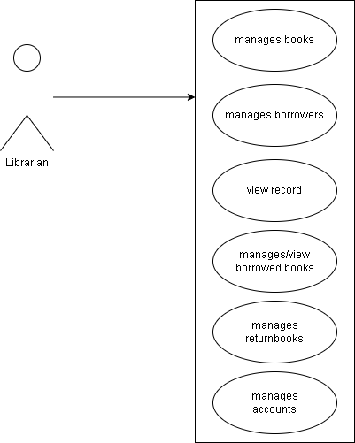

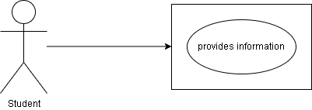

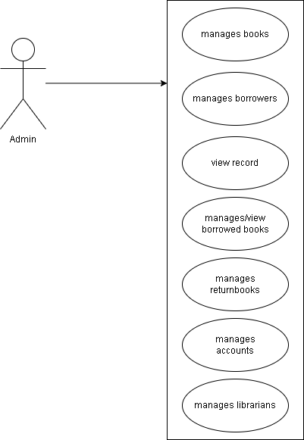

**1.11: ERD Diagram –** backend (database) – explain the connections among tables

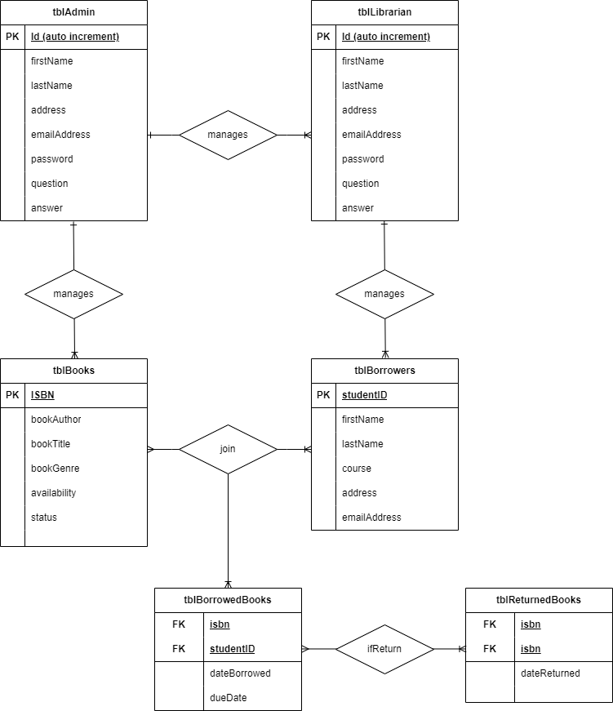

**Chapter II: Review of Related Literature and Studies**

**2.1 Review of Related Studies**

**2.1.1 Local Studies**

**Title of the study**: De La Salle University Library System Migration: Strategic Decision

**Proponents**: Perla T. Garcia

**Date of Implementation:** March 15, 2004

**Summary:**

The proponent of De La Salle University implemented a new library system. The University Library considered several factors when they decided to replace their outdated T-Series OPAC (online public access catalog) system with a new one that could meet the expanding demands of users. Technical development and vendor stability, networking, expansion of databases, adherence to standards, support for migration, capability of expansion, support of the vendor, networking capability, flexibility of the system, production of management and statistical reports, and stability of the vendor were the main factors considered in selecting a new system.

**Relation:**

The proponents of CLMS also decided to use a database. Databases provide an efficient and organized way to store, manage, and retrieve large amounts of data, improving data accuracy, accessibility, and security.

**Title of the study:** Public High Schools Online Library System (University of the Philippines Manila)

**Proponents:** Analee E. Mayo

**Date of Implementation:** February 2016

**Summary:**

The proponent of University of the Philippines implemented a Public High Schools Library System. The Public High Schools Library System has a website with a homepage where users can login or sign up for an account. The sign-up page requires the user’s name, password, email address, user type, and year level (for students). Once logged in, users can browse the library collection through basic search and view search results. The librarian has access to reading material management tools such as adding, editing, and deleting books from the online catalog, and managing library user accounts and borrowing. The website also has features for tracking reading material usage and monitoring users’ overdue books.

**Relation:**

The proponents of CLMS also have a feature particularly for librarians and school administrators. The CLMS can explore similar library systems and evaluate their effectiveness in promoting literacy and supporting student learning.

**Title of the study:** Web-based Library Management System with SMS Notifications for Cainta Catholic College

**Proponents:**

Lara Jane Balin

Verna Mae Gabito

Mariell Cabalan

Alexandra Abayon

Date of Implementation: 2022

**Summary:**

The proponents implemented a web-based Library Management System with SMS notification to address the issues of the current manual library system and to achieve the objective of creating a more efficient and user-friendly system for Cainta Catholic School libraries.

**Relation:**

The proponents of CLMS also applied the idea of process of borrowing and returning books to achieve the objective of creating a more efficient and user-friendly system

**2.1.2 Foreign Studies**

**Title of the study**: Library Management System in Xi’an University of Architecture & Technology

**Proponents:**

Shanmugam, AP

Ramalakshmi, A

Sasthri, G

Baalachandran, S

**Date implemented:** November 2020

**Summary:**

The proponents Xi’an University of Architecture & Technology proposed a Library Management System (LMS) contains an Admin module where the authorized person, the Admin, can access the system through a user id and password. Once logged in, the Admin can add student and book details, issue and return books, view and update book and student details, and search for books through the search option in the LMS. The LMS was implemented using .Net for the front end and SQL for the back end. The system eliminates the disadvantages of the existing manual system, such as the risk of entry tampering and the clumsiness of the system, and provides a user-friendly environment for the librarians.

**Relation:**

The proponents of CLMS also provides insights on the features and functionality of a proposed Library Management System. It can help us understand the components that should be included in our own system and how it can benefit the library.

**Title of the study:** LIBRARY MANAGEMENT SYSTEM WITH TOPIC MODELLING AND ITS ADAPTABILITY TO OPEN AND DISTANCE LEARNING LIBRARIES

**Proponents:** Babafemi RICHARD Adebayo

**Date implemented:** 2019

**Summary:**

The proponent of University of Nebraska explores how Latent Dirichlet Allocation (LDA) can be integrated into a web-based library management system. The system, called Integrated Library System with Topic Modeling, was developed using C# and asp.net as its web framework with SQL as its back end. The system allows users to manage and search textual and graphical resources online. The study recommends further application of topic modeling in library management systems, particularly in Open and Distance Learning platforms. The use of LDA in library management systems can improve productivity, time management, and decision-making. This study contributes to the knowledge by introducing new ways of search and exploration in library management systems.

**Relation:**

The proponents of CLMS also use SQL as its back end. SQL has numerous benefits for managing and manipulating relational databases, including efficient data retrieval, scalability, ease of use, data integrity, and flexibility in supporting complex queries and transactions.

**Title of the study:** Design and Development of an Electronic Library Management System for Mufulira Skills Training Institute.

**Proponents:** Stephen Sikatema Masiye

Date implemented: 2019

**Summary:**

The proponent of Engineering Information and Communications University, discusses the technology used and the results of the Electronic Library Management System study. The system uses PHP, JavaScript, JQuery Library, Bootstrap, CSS, Ajax, and HTML5 for coding, and Adobe Dream Weaver CS6, Adobe Photoshop CS4, Microsoft Visio 2010, and Microsoft Word 2010 for development. The system improves services, reduces costs, and ensures privacy and security. It is similar to other library management systems but with different features. The system can be applied to various learning institutions, enterprises, and libraries. The study concludes that the system is efficient, usable, and reliable, and future works include integrating payment systems and adding multiple currency options.

**Relation:**

The proponents of CLMS also decided to focus on the benefits and features of the system. The proponents also highlight the importance of user experience and security in designing such systems.

**2.2 Review of Related Literature**

**2.2.1 Local Literature**

**Title of the article:** Automated library management system for public libraries in the Philippines

**Author:** Aldrin Padilla Obsanga, Ribert Roque Enierga

**Date Implemented:** November 15, 2021

**Summary:**

The goal of this study is to create a computerized system that will improve library activity efficiency and oversight, giving librarians and library customers simple access to library use.

**Relation:**

The proponents of this study also created a method at the library to decrease the trouble of the librarian tracking any movement of the book that is being borrowed by the students. This is how this study relates to the literature that was previously mentioned. It will be simpler for them because the librarian can access their own record in the system where they can see what books are being borrowed and whether or not the students have already returned the books, rather than having to wait for the students to fill out a form.

**Title of the article:** Proposed Library System for Bestlink College of the Philippines

**Author:**

Jerome Abuan

Marivic Agliron

Joel Raymundo Cajipe

Date Implemented: March 2020

**Summary:**

The use of computer software for simple management and log book upkeep improved the library system. To persuade the member to browse books and borrow books from the library, a library system was created. By automating operations, this system can save time and keep data secure for only authorized users. The technology was very straightforward and simple to use. To accomplish our objectives, we adopted the systems development life cycle process. The lack of security was one issue our client saw with the present library system. We created a login mechanism to safeguard the current library system in order to solve this issue. For the purpose of assisting users in encoding book records, the current library system was improved. The client will decide whether to employ the suggested system or stick with the present library system.

**Relation:**

In order to make it easier for the librarian to track any movement of the books that the students are borrowing, the study's proponents also devised a system for the library. This is how the study connects to the earlier-mentioned literature. Instead of waiting for the students to fill out a form, the librarian may access their own record in the system to see what books are being borrowed and whether or not the students have already returned the books, making it easier for them. As a result of being saved in the system and having a low probability of being erased, it can save time while also ensuring the safety of the records.

**Title of the article:** Library Automation: An Emerging Technology for State University and Colleges in Sulu Province

**Author:** Shernahar K. Tahil

**Date Implemented:** March 2020

**Summary:**

The library is one of the most crucial locations in every academic establishment and is still the go-to site for knowledge for many people, including students, instructors, and others. The goal of this literature research was to describe technological development in library management. The development of technologies can benefit the library in a number of ways. The adoption of new technology by libraries will enable them to operate and function effectively, boosting productivity and enhancing user services without adding staff. Fortunately, new technologies have produced radio frequency identification (RFID), digital libraries, quick response codes, and barcode systems. Therefore, using these technologies offers a complete solution for simple library operation, including book borrowing and return, book searching and location, and book record maintenance. To suit user needs, it is essential to develop and improve library services.

**Relation:**

In regard to the literature that was previously discussed, the authors of this study also developed a system for the library that will make it easier for the librarian to keep track of any movement of the books that students are borrowing. Instead of waiting for the students to fill out a form, the librarian may access their own record in the system to see what books are being borrowed and whether or not the students have already returned the books, making it easier for them. Since the records were saved in a system, it can also give further assurance regarding the security of the records.

**2.2.2 Foreign Literature**

**Title of Article:** The Future of the Library Management System

**Author:** Yet Marshall Breeding

**Date Implemented:** 2012

**Summary:**

The Library Management System (LMS), also referred to as Integrated Library System (ILS), is the lynchpin of library automation. Yet Marshall Breeding, library technology guru and one of the main writers on the subject, forecast its demise at the American Library Association's Midwinter 2012 meeting (Rapp, 2012).

**Relation:**

This article looks at trends in LMS, and examines whether the above claim has any truth in it.

Relation: The proponents of CLMS also used Multifunction, adaptable software applications that allow libraries to manage, catalog and circulate their materials to patrons

**Title of Article**: Library Management and Innovation in the Big Data Era

**Author**: V Mayer- Schönberger and K. Cukier

**Date Implemented:** 2013

**Summary:**

Big data has become a significant area nowadays and received considerable attention in both research and practice. The well-known book “Big data: A revolution that will transform how we live, work, and think. In 2013 was cited over 1400 times based on Google Scholar. Some other books on Big Data have drawn hundreds of citations.

**Relation:**

The proponents of CLMS also used Different library tools offers innovative ways of understanding interactions with users in the library environment.

**Title of Article**: Meet the editor of Library Management

**Author:** Ed Evans

**Date Implemented**: 2009

**Summary:**

Library Management (LM) contains peer reviewed articles aimed at academics and senior managers within the library and information services (LIS) discipline or profession. It tackles a wide range of general management issues such as strategic management, human resources, finance and performance measurement, as well as new technological developments and how to future-proof the profession.

**Relation:**

The proponents of CLMS also used general management issues such as strategic management, human resources, finance and performance measurement.

**2.3 Synthesis**

These six studies all relate to the topic of library management systems. The studies discuss the implementation of different library systems, the features they have, and the benefits they bring. Some of the features that are discussed include user logins, book management, borrowing and returning processes, statistical reporting, and SMS notifications. The studies also highlight the use of certain technologies, such as SQL, PHP, JavaScript, and asp.net. Overall, these studies provide insights and recommendations on how to create more efficient and user-friendly library management systems.

This set of articles discusses the implementation and benefits of automated library management systems in various libraries in the Philippines. The authors highlight the importance of technology in improving library efficiency and services, including the use of computer software for management and record-keeping, as well as technologies such as radio frequency identification, digital libraries, quick response codes, and barcode systems. The articles also address concerns around data security and the future of library management systems. Overall, the authors argue that implementing automated library management systems can benefit librarians, students, and other users by increasing productivity and enhancing user services.

**________________________________________**

**Approver’s Name**